

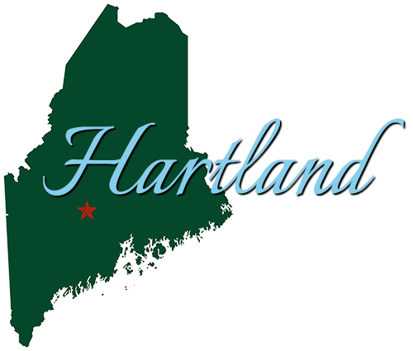


Understanding Your New Property Assessment
Prepared for residents of Hartland

Prepared By:
Municipal Consulting Group of Maine

48 Liberty Drive, Hermon, ME 04401
PHONE: (207) 605-0200
EMAIL: hartland@mcgmaine.com
WEBSITE: www.mcgmaine.com

1. Understanding Your New Property Assessment
Hartland recently completed a town-wide property revaluation, working with Municipal Consulting Group of Maine. A change in your property's assessed value can raise questions, and this guide is here to help answer them. As always, for any specific questions or for more information, please contact Municipal Consulting Group of Maine at (207) 605-0200. If you have concerns about your assessment, you have options, and those are outlined in this guide as well.

2. What Does This Number Mean?
Your property assessment is an estimate of what your property would likely sell for based on current market conditions and recent sales of similar properties. It's not a number someone invented. It's based on actual market data, including what properties like yours have recently sold for, along with your property's physical characteristics.
State law requires municipalities to assess property at market value. This applies whether you're planning to sell or not. It's how the state requires communities to distribute the property tax obligation fairly across all property owners.
Your assessment is one of the components used to calculate property taxes. It is not the same as your tax bill.

3. Why Did My Assessment Change?
Assessments reflect the real estate market. When market conditions change, assessments are updated to match what properties are currently selling for. A revaluation updates every property at the same time so values are consistent and equitable across the community.
Different properties change by different amounts. How much yours changed depends on your property type, location, features, and how your previous assessment compared to current market conditions. A property that was already assessed close to market value may see a smaller change than one that was further off. This is why your assessment may have changed more or less than a neighbor's.
Individual changes can also result from building permits, property improvements, or corrections to property records.

4. Does a Higher Assessment Mean Higher Taxes?
This is the question most people have, and the honest answer is: it depends on several things, not just your assessment.
Your property tax is based on two things. What your property is assessed at, and the tax rate your town or city sets each year based on its budget. The tax rate is calculated by dividing the total approved budget by the total assessed value of all properties in your community.
When assessments change across a community, the tax rate typically adjusts too. The two work together. What your individual tax bill looks like depends on how your property's value changed relative to other properties in your community, and on what the municipal budget looks like that year.
A revaluation updates assessments. It doesn't, by itself, change how much money your municipality raises in taxes. Those are separate decisions made through the budget process.
For questions about your community's budget, tax rate, or how this may apply to your specific situation, contact your town or city office.

5. Concerned About Property Tax Affordability?
There are exemptions and programs at the state and local level that may help with property tax burden. Eligibility and availability vary by community. Contact your town or city office to ask what may be available, or visit the Maine Revenue Services website for information on state programs.

6. How Can I Check My Property Information?
Your town or city maintains a record for each property that includes the information used to calculate the assessment. This includes lot size, building dimensions, number of rooms, property condition, and other characteristics.
You can review your property record by contacting the assessor's office or visiting the town or city office during business hours. Some communities also offer online access to property records through their website.
If you believe any information in your property record is inaccurate or incomplete, that's a good reason to reach out. Having accurate records helps ensure your assessment reflects your property as it actually is.

7. What If I Have Questions or Concerns About My Assessment?
Reviewing your assessment and asking questions is a normal part of the process. Residents do it every year, and your town or city office is set up to help.
Start with a conversation. If you have questions about how your assessment was determined, contact your local assessor's office or town or city office. Staff can explain what information was used and how your property compares to similar properties. This is the best first step for most questions.
Informal review. Many communities offer an informal review period after new assessments are issued. This is an opportunity to sit down with the assessor, review the data on your property, and discuss any concerns before the formal process begins. Contact your town or city office to find out if an informal review period is available and how to participate.
Formal abatement. If your concern isn't resolved through conversation or informal review, Maine law provides a formal abatement process. This involves submitting a written application to the municipality within 185 days from the date of commitment. The assessor and revaluation company will review the application and issue a decision within 60 days. If you have concerns about your assessment, don't wait. Start with a phone call to your town or city office to learn more about the process.
How to prepare for the conversation. If you plan to discuss your assessment with the assessor's office, it can help to have the following:
- Your assessment notice.
- Any information about your property you believe may not be reflected in the records, such as condition issues, needed repairs, or features that differ from what's on file.
- If available, recent sale prices of properties you consider comparable to yours.
You don't need to bring all of this. A phone call with questions is always a fine place to start.

8. Questions?
Your town or city office is available to help at any point in this process. Whether you want to understand your number, check your property information, or discuss your options, the first step is the same: reach out.

Municipal Consulting Group of Maine
48 Liberty Drive, Hermon Maine, 04401
(207) 605-0200
hartland@mcgmaine.com
mcgmaine.com/hartland-revaluation

